# CS 255 System Design Document Template

This template lays out all the different sections that you need to complete for Project Two. Each section has guidance to prompt your thinking. You will need to continually reference the interview transcript as you work to make sure that you are addressing your client’s needs. There is no required length for the final document. Instead the goal is to complete each section based on what your client’s needs are. Remove this note when you are finished, and replace all bracketed text with the relevant information.

## UML Diagrams

### UML Use Case Diagram

*[In Module Six, you were asked to complete a use case diagram based on your system design. If you would like to make any adjustments to your diagram, please do so. Please insert your use case diagram here. Check to make sure that you included appropriate components and symbols and that your design meets the client’s needs.]*

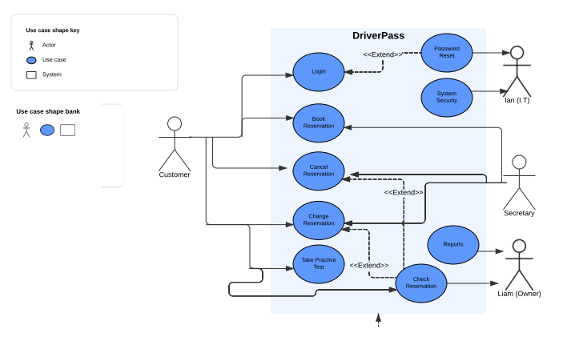

### UML Activity Diagrams

*[You were asked to choose* ***two*** *use cases and create* ***two*** *activity diagrams, one for each use case. Please insert* ***both*** *of your activity diagrams here. Check to make sure that you included appropriate components and symbols and that your design meets the client’s needs.]*

*My first Activity diagram is logging in. The second is making a reservation.*

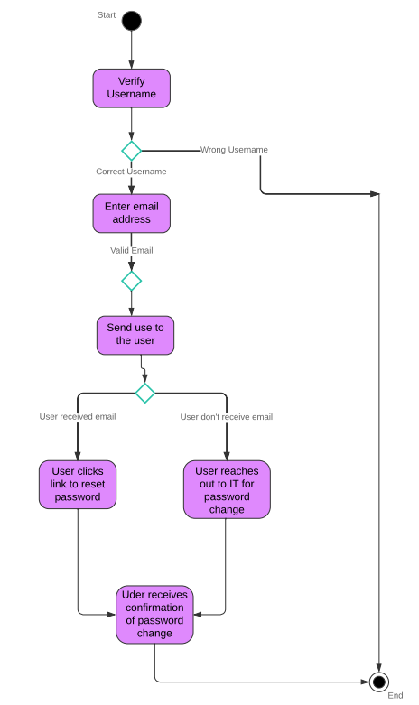

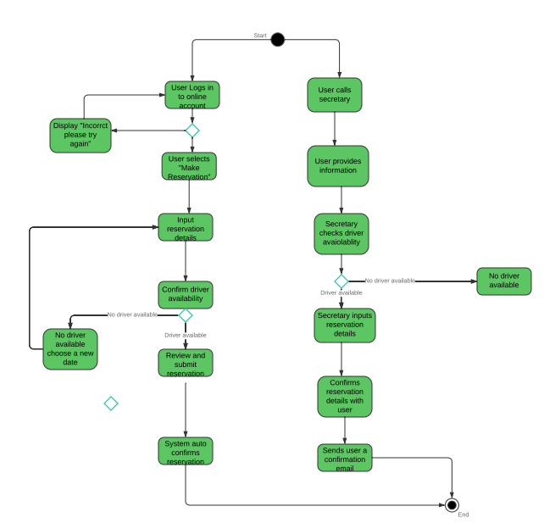

### UML Sequence Diagram

*[You were asked to create a sequence diagram based on* ***one*** *of the use cases you chose. Please insert your sequence diagram here. Check to make sure that you included appropriate components and symbols and that your design meets the client’s needs.]*

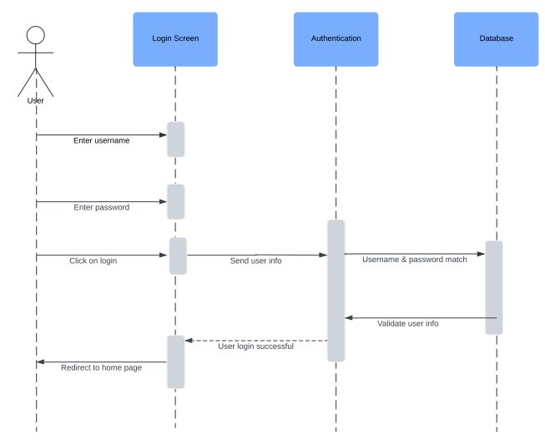

### UML Class Diagram

*[You were asked to create a class diagram based on the different classes and attributes needed for your system design. You are* ***not*** *required to include methods, but you may if you wish. Please insert your class diagram here. Check to make sure that you included appropriate components and symbols and that your design meets the client’s requirements.]*

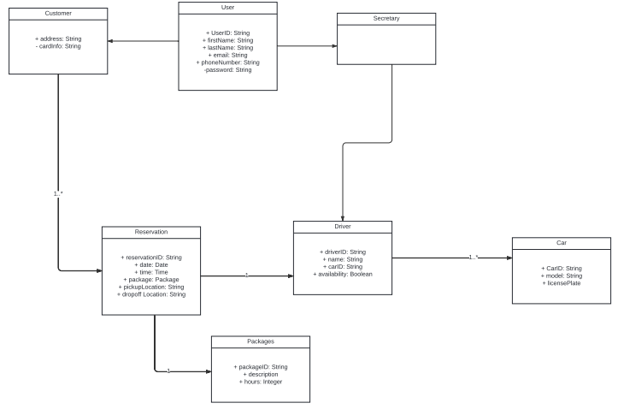

## Technical Requirements

*[Based on the diagrams you have created, describe the technical requirements of your system. These requirements should address the required hardware, software, tools, and infrastructure necessary for your system design.]*

*The hardware needed for The DriverPass system includes servers, so that the computers can handle all the requests that are coming in from users, a web server to show the website and a database server to store all the information about customers and their reservations, laptop/desktop computers for the staff and mobile devices for customers to use the system on the go, and routers/firewalls to keep the network secure. For software we need an operating system, for the servers. For the website, we’ll use JavaScript to make it look good and work well. On the backend, we can use Django as a framework to handle the logic. We also need a database system, to keep track of user information and reservations. To help the developers, tools like Visual Studio Code and Git will be important for writing and managing the code. As for infrastructure, we might consider using cloud services. These are online services that can help us store data and run applications without needing to buy and maintain physical servers. Backup solutions are also important to make sure we don’t lose any data. We can use tools to monitor how the system is performing and check for any issues. Setting up secure logins so that customers can create accounts and make reservations safely. We’ll have different roles for users, so everyone has the right level of access to do their jobs.*